

Schools must use the funding to make additional and sustainable improvements to the quality of PE and sport they offer. This means that you should use the Primary PE and Sport Premium to:

- develop or add to the PE and sport activities that your school already offers
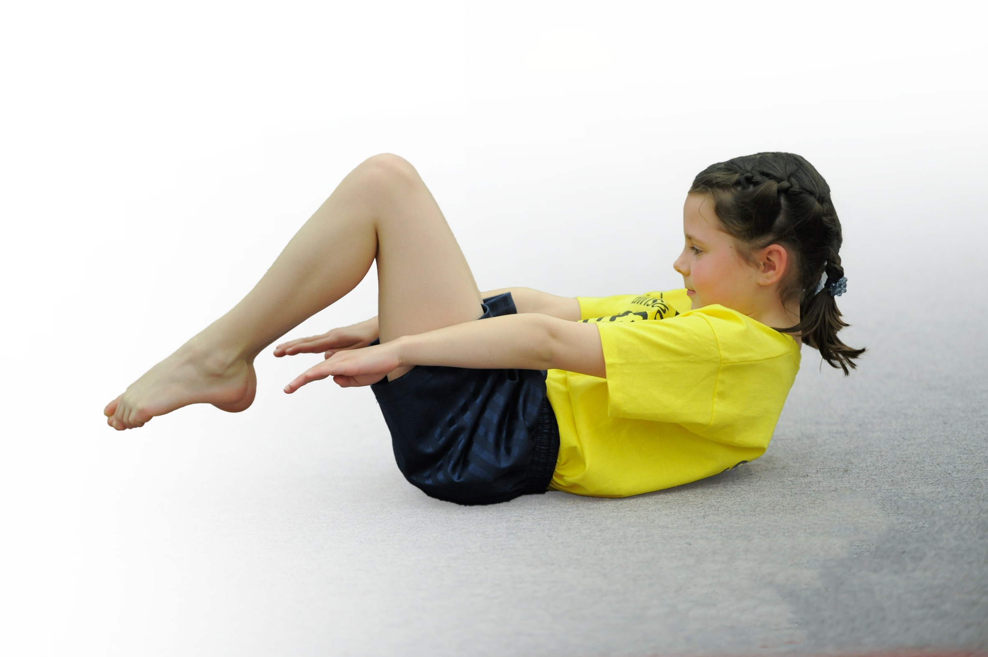
- build capacity and capability within the school to ensure that improvements made now will benefit pupils joining the school in future years

Support for review and reflection - considering the 5 key indicators from DfE, what development needs are a priority for your setting and your students now and why? Use the space below to reflect on previous spend, identify current need and priorities for the future.
Walkeringham Primary School Sports Funding accountability 2018-2019.

Key achievements to date: 2018-2019 | Areas for further improvement and baseline evidence of need:
- Dance Day for festivals and Celebrations each half term e.g. Diwali, Chinese New Year,  - Establish Dance, PE, Taekwondo, and Running Clubs.  - All Children in KS 2 swam.  - All children Nursery-Yr. 6 participate in a wide range of activities.  - Trained Year 6 as Sports leaders.  - Nursery, Reception and Year 1 dance weekly  - KS 2 pupils participated in 8 week cricket coaching  - All children in Year 3,4,5,& 6 (except 1 ) took part in a residential activity holiday in Derbyshire including canoeing, rock climbing, stream scrambling, abseiling.  - Yr 5 and 6 had an introduction to sailing – 1 day course. | - Interschool sports.  - Introduce a further range of aspirational sports and activities, e.g. fencing to school.

Meeting national curriculum requirements for swimming and water safety | Please complete all of the below.
What percentage of your current Year 6 cohort swim competently, confidently and proficiently over a distance of at least 25 metres? | 9/9  100%
What percentage of your current Year 6 cohort use a range of strokes effectively [for example, front crawl, backstroke and breaststroke]? | 9/9  100%
What percentage of your current Year 6 cohort perform safe self-rescue in different water-based situations? | 8/9 (NCC Stage 6)  89%
Schools can choose to use the Primary PE and Sport Premium to provide additional provision for swimming but this must be for activity over and above the national curriculum requirements. Have you used it in this way? | Yes – For Key Stage 1

Action Plan and Budget Tracking
Capture your intended annual spend against the 5 key indicators. Clarify the success criteria and evidence of impact that you intend to measure to evaluate for students today and for the future.

Academic Year: 2017/18 | Total fund allocated: £16570 | Date Updated: 09.07.2018
Key indicator 1: The engagement of all pupils in regular physical activity – Chief Medical Officer guidelines recommend that primary school children undertake at least 30 minutes of physical activity a day in school |  |  |  | Percentage of total allocation:
 |  |  |  | £11834/ £16570 =71 %
School focus with clarity on intended impact on pupils: | Actions to achieve: | Funding allocated: | Evidence and impact: | Sustainability and suggested next steps:
1. To ensure that all children experience a wide range of activities and opportunities to expose them to a variety with the aspiration that each child will discover something that they love and be inspired to pursue the activity out of school as well.  2.Nursery , Reception and Year 1 children to participate in weekly dance activities “Boogie Bear”  3)School swimming for years 3,4,5, & 6  A half termly day of dance to celebrtae festivals, diversity, etc | - Plan with the Sports coach a broad and aspirational range of activities.  - Plan with community/school partners a range of aspirational opportunities e.g. sailing, cricket coaching  All pupils to achieve all Boogie bear targets each term  All Yr. 6 pupils to meet over 25 metres swimming target. | £7410  £1300  £2224  £900 | Pupils look fit and are active.  All pupils report loving their Sport Wednesday day  Many pupils are active out of school.  Good % sign up to after school clubs between 15-20% of school weekly 10/15 of 65 Full time children.  Children adore dancing and are very skillful and rhythmical.  % of children who stay on to after school dance club.  Swimming staff report that pupils have proficiency in the water, and all are able to swim at least 25m confidently. | For staff to regularly plan for “Activate” at the start of school.  Extend the in-school dance session to all years in school.  Investigate a different swimming option with different timescales and see if we can collaborate with another local school to reduce costs.
Key indicator 2: The profile of PE and sport being raised across the school as a tool for whole school improvement |  |  |  | Percentage of total allocation:
 |  |  |  | £2000/£16570 = 12 %
School focus with clarity on intended impact on pupils: | Actions to achieve: | Funding allocated: | Evidence and impact: | Sustainability and suggested next steps:
Year 6 trained as “Sports leaders” to lead activities at playtime and lunchtimes each day  Play equipment investment and repairs | To ensure all children from R- Yr.6 encouraged to participate in a physical activity daily. | £2000 | Many children involved in parachute activities and team sports at playtimes and breaks. | School council to monitor the play equipment and to choose types of equipment following pupil survey.  Invest in school fencing equipment.

Key indicator 3: Increased confidence, knowledge and skills of all staff in teaching PE and sport |  |  |  | Percentage of total allocation:
 |  |  |  | £100/£16570 = 6 %
School focus with clarity on intended  impact on pupils: | Actions to achieve: | Funding  allocated: | Evidence and impact: | Sustainability and suggested  next steps:
School Sports coach to train and support breakfast club and teatime club staff with physical activities that children can do at before and after school clubs. e.g. Boccia, skittles, bowls, badminton etc.  Staff organising activity-based school trips.  Staff working alongside specialist staff to broaden confidence in off-site activities and participation and motivation for all children. | Increase confidence in support staff for a range of planned for activities.  Activity/ team building survival visit to Sherwood forest  4 day residential for all (except 1) Year 3,4,5& 6 children | £100  £124  £650 | Observe and work alongside Sports coach staff to deliver high quality activity sessions.  Pupils prone to anxiety achieved huge milestones e.g. abseiling, climbing.  Pupils report high levels of satisfaction and engagement with activities. | - Observe activities and how to organise for groups of pupils.  - Team teach activities  - School council & Pupil voice questionnaires  Investigate the potential of organising the trip annually.
Key indicator 4: Broader experience of a range of sports and activities offered to all pupils |  |  |  | Percentage of total allocation:
 |  |  |  | £1605/£16570 = 10 %
School focus with clarity on intended  impact on pupils: | Actions to achieve: | Funding  allocated: | Evidence and impact: | Sustainability and suggested  next steps:
Additional achievements:  An agreed range of activities planned for with sports coach to include aspirational activities e.g. fencing orienteering  Local clubs e.g. Taekwondo invited into school to give taster sessions.  Establishing after school clubs 4 days per week.  Introduction to sailing for years 5 & 6 | Buy fencing equipment | £500  £1105  £200 | Wide range of activities pursued by pupils after school who report that in school opportunity has inspired them e.g. Children from Taekwondo who have gone to local club and taken part in grading process.  Children have a choice of clubs and can choose what they like.  School council helps inform the choice.  High levels of participation and enjoyment from children. | - Invite more sports clubs/ambassadors into school to inspire the pupils.  Measure the individual number of children in school who attend a club and report as a %  Maintain links with the sailing club to encourage children to anticipate in weekend and family day’s sailing club.
Key indicator 5: Increased participation in competitive sport |  |  |  | Percentage of total allocation:
 |  |  |  | £100/£16570 = 1 %
School focus with clarity on intended  impact on pupils: | Actions to achieve: | Funding  allocated: | Evidence and impact: | Sustainability and suggested  next steps:
In school competitions  Attending Inter school athletics at Senior school. |  | FREE  £110 | Motivation and achievement of all groups of children.  Opportunity for pupils from a very small primary school to attend a large function and meet potential secondary school class mates. | To organise regular inter school and in school competitions within school time.

