
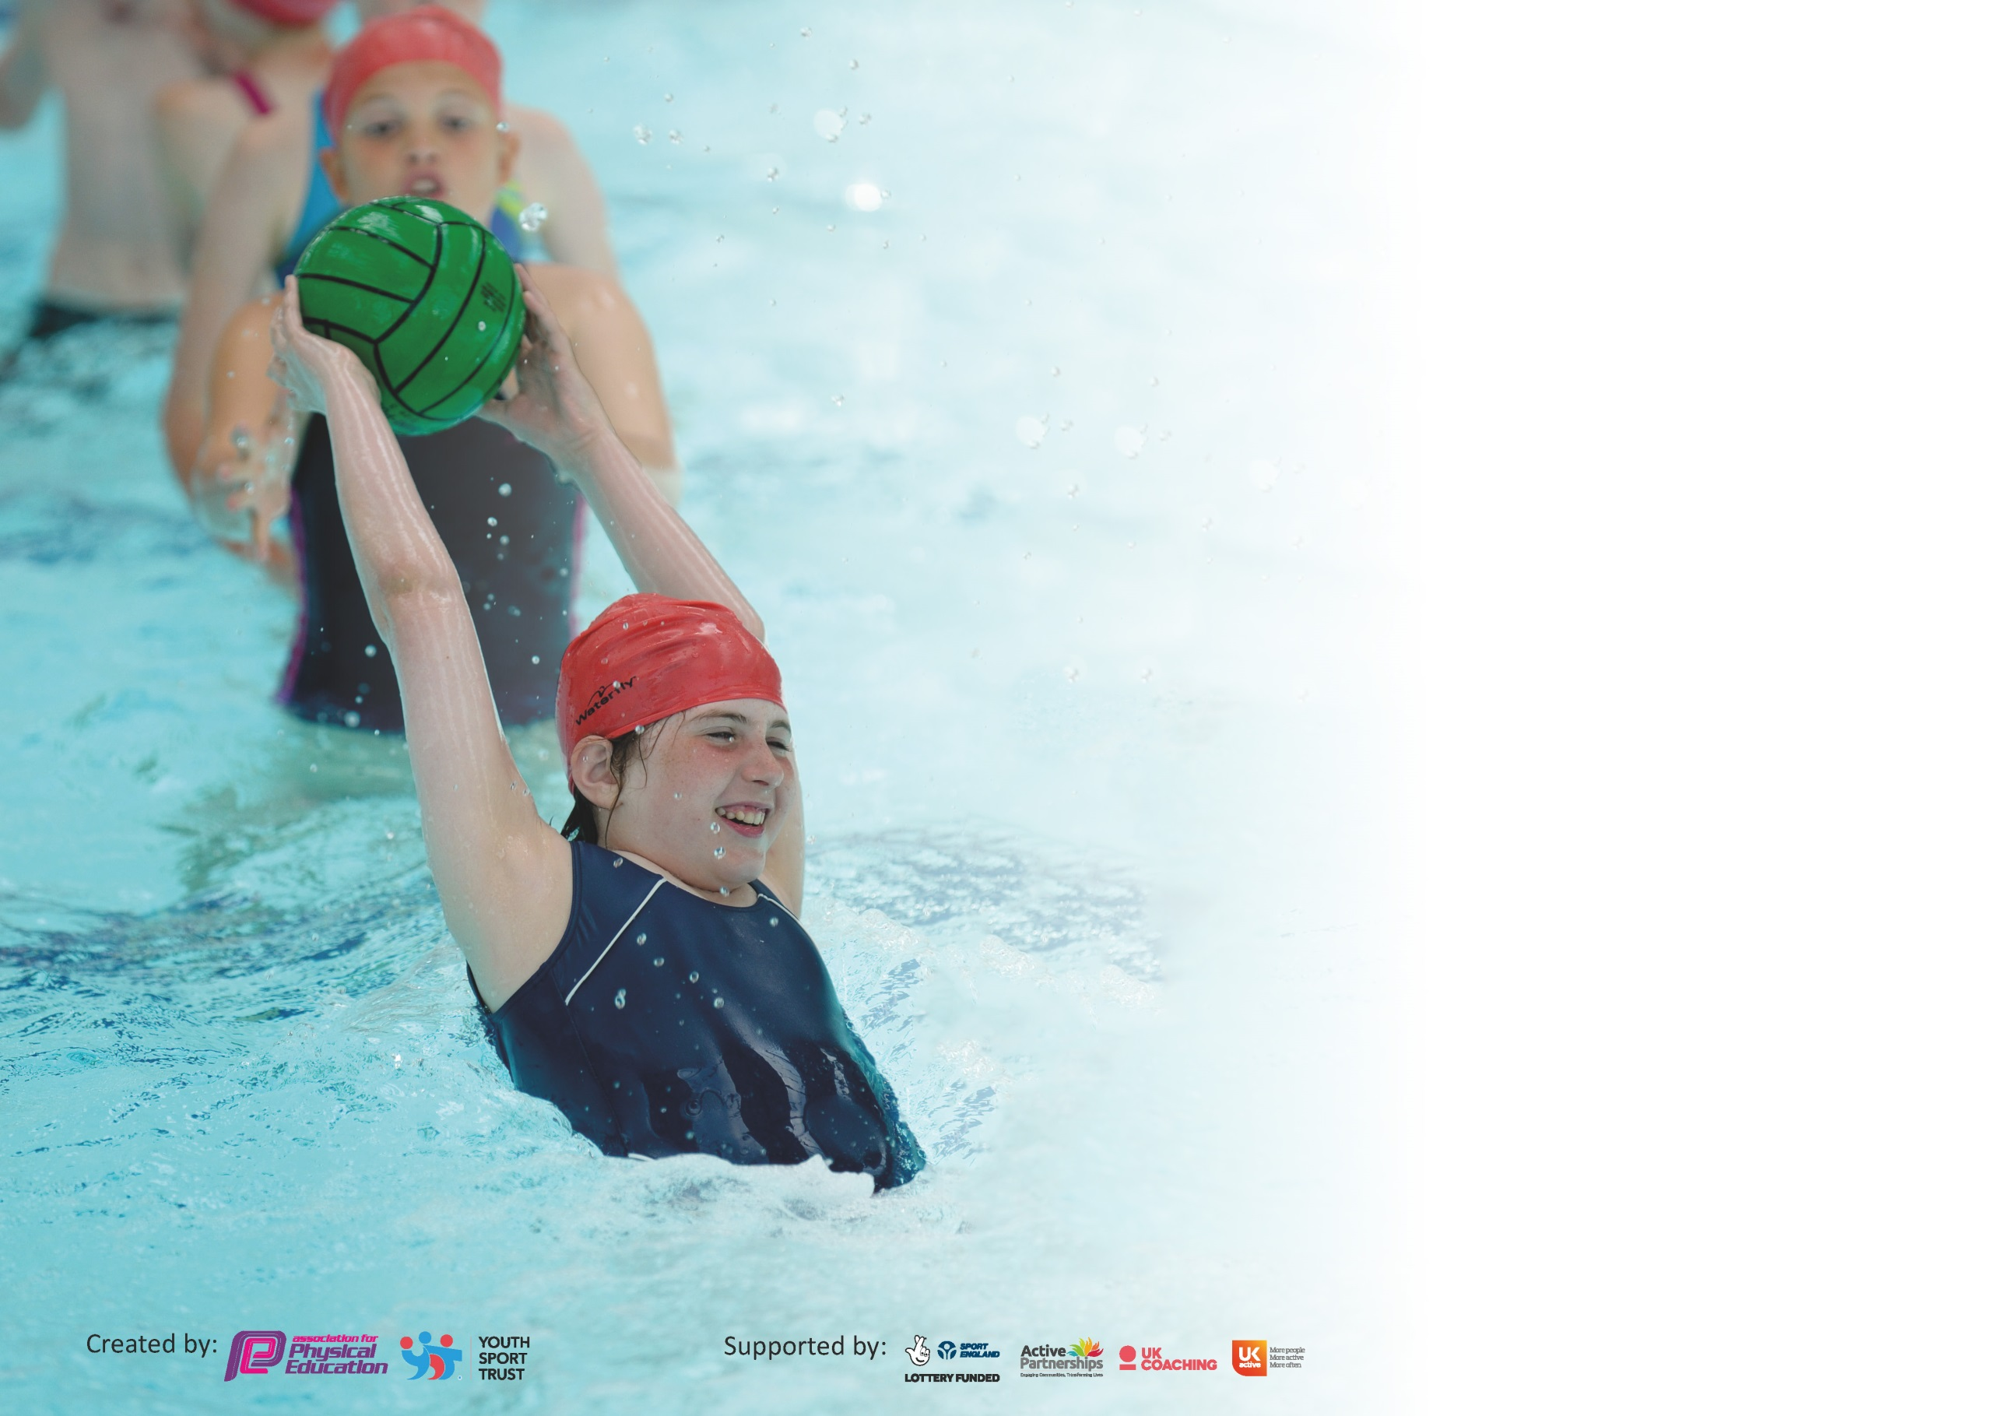

It is important that your grant is used effectively and based on school need. The Education Inspection Framework (Ofsted 2019 p64) makes clear there will be a focus on ‘whether leaders and those responsible for governors all understand their respective roles and perform these in a way that enhances the effectiveness of the school’.

Under the Quality of Education criteria (p41) inspectors consider the extent to which schools can articulate their curriculum (INTENT), construct their curriculum (IMPLEMENTATION) and demonstrate the outcomes which result (IMPACT).

To assist schools with common transferable language this template has been developed to utilise the same three headings which should make your plans easily transferable between working documents.

Schools must use the funding to make additional and sustainable improvements to the quality of Physical Education, School Sport and Physical Activity (PESSPA) they offer. This means that you should
use the Primary PE and Sport Premium to:

- Develop or add to the PESSPA activities that your school already offer
- Build capacity and capability within the school to ensure that improvements made now will benefit pupils joining the school in future years

Please visit gov.uk for the revised DfE guidance including the 5 key indicators across which schools should demonstrate an improvement. This document will help you to review your provision and to report your spend. DfE encourages schools to use this template as an effective way of meeting the reporting requirements of the Primary PE and Sport Premium.

We recommend you start by reflecting on the impact of current provision and reviewing the previous spend.

Schools are required to publish details of how they spend this funding as well as on the impact it has on pupils’ PE and sport participation and attainment by the end of the summer term or by 31st July 2020 at the latest.

We recommend regularly updating the table and publishing it on your website throughout the year. This evidences your ongoing self-evaluation of how you are using the funding to secure maximum, sustainable impact. Final copy must be posted on your website by the end of the academic year and no later than the 31st July 2020. To see an example of how to complete the table please click HERE.

Walkeringham Primary School 2019-20
Support for review and reflection - considering the 5 key indicators from DfE, what development needs are a priority for your setting and your pupils now and why? Use the space below to reflect on previous spend and key achievements and areas for development.

Key achievements to date until July 2019: | Areas for further improvement and baseline evidence of need:
- Continue to provide Dance and PE afterschool clubs.  - Dance Day for festivals and Celebrations each half term e.g. Diwali, Chinese New Year,  - All children Nursery-Yr. 6 participate in a wide range of activities.  - All children in Year 3,4,5,& 6 (except 1 ) took part in a residential activity holiday in Derbyshire including canoeing, rock climbing, stream scrambling, abseiling.  - Trained Year 6 as Sports leaders.  - Nursery, Reception and Year 1 dance weekly  - Year 3 & 4 received specialist dance sessions.  - Due to the November floods and school being taught across two sites many of our planned activities could not take place. | - Interschool sports.  - Introduce a further range of aspirational sports and activities, e.g. archery and fencing to school.  - Joint Bassetlaw School Games Organisation  - All children from Year 2-6 to take part in swimming lessons  - Yr 5/6 to take part in Swimming galas and additional swimming skills.  - Key stage 2 children to take part in a residential activity holiday in Derbyshire including canoeing, rock climbing, stream scrambling, abseiling – Covid permitting.

Meeting national curriculum requirements for swimming and water safety. Swimming was 2018-19 school year.
What percentage of your current Year 6 cohort swim competently, confidently and proficiently over a distance of at least 25 metres?  N.B. Even though your pupils may swim in another year please report on their attainment on leaving  primary school at the end of the summer term 2020. | 67%
What percentage of your current Year 6 cohort use a range of strokes effectively [for example, front crawl, backstroke and breaststroke]? | 67%
What percentage of your current Year 6 cohort perform safe self-rescue in different water-based situations? | 67%
Schools can choose to use the Primary PE and Sport Premium to provide additional provision for swimming but this must be for activity over and above the national curriculum requirements. Have you used it in this way? | No

Action Plan and Budget Tracking
Capture your intended annual spend against the 5 key indicators. Clarify the success criteria and evidence of impact that you intend to measure to evaluate for pupils today and for the future.

Academic Year: 2019/20 | Total fund allocated: £16000 | Date Updated:July 2020
Key indicator 1: The engagement of all pupils in regular physical activity – Chief Medical Officer guidelines recommend that primary school pupils undertake at least 30 minutes of physical activity a day in school |  |  |  | Percentage of total allocation:
 |  |  |  | %
Intent | Implementation |  | Impact | 33%
Your school focus should be clear what you want the pupils to know and be able to do and about  what they need to learn and to  consolidate through practice: | Make sure your actions to achieve are linked to your intentions: | Funding allocated: | Evidence of impact: what do pupils now know and what can they now do? What has changed?: | Sustainability and suggested next steps:
To ensure that all children experience a wide range of activities and opportunities to expose them to a variety with the aspiration that each child will discover something that they love and be inspired to pursue the activity out of school as well.  Nursery , Reception and Year 1 children to participate in weekly dance activities “Boogie Bear” | Plan with the Sports coach a broad and aspirational range of activities.  Plan with community/school partners a range of aspirational opportunities e.g. sailing, cricket coaching, rugby  All pupils to achieve all Boogie bear targets each term | £5300 | Pupils look fit and are active.  All pupils report loving their Sport Wednesday day  Many pupils are active out of school.  Children enjoy dancing and are skilful and rhythmical. | For staff to regularly plan for an active session at the start of the school day.  Extend the in-school dance session to all years in school.
Key indicator 2: The profile of PESSPA being raised across the school as a tool for whole school improvement |  |  |  | Percentage of total allocation:
 |  |  |  | %
Intent | Implementation |  | Impact | 6
Your school focus should be clear what you want the pupils to know and be able to do and about  what they need to learn and to  consolidate through practice: | Make sure your actions to achieve are linked to your intentions: | Funding allocated: | Evidence of impact: what do pupils now know and what can they now do? What has changed?: | Sustainability and suggested next steps:
Year 6 to take on responsibility for encouraging games and team sports during play and dinner time.  Encourage children to work together to raise funds for new equipment  Play equipment investment and repairs | Develop Young Leader training with external coach.  Take part in the Aldi collecting for Sport programme | £1000 | Children trained – Flooding disrupted due to split site and staggered break times.  Tracker completed and sports equipment bag received in school. Children able to see the impact of working together. | Look at re-training for current Y5 and Y6 for sustainability. Y5 to train new Y5’s next year.  Continue to use the equipment in future years. Ask school council to ask children what sport equipment they would like and ways to fund raise for this via a questionnaire.

Key indicator 3: Increased confidence, knowledge and skills of all staff in teaching PE and sport |  |  |  | Percentage of total allocation:
 |  |  |  | %
Intent | Implementation |  | Impact | 16
Your school focus should be clear | Make sure your actions to | Funding | Evidence of impact: what do | Sustainability and suggested
what you want the pupils to know | achieve are linked to your | allocated: | pupils now know and what | next steps:
and be able to do and about | intentions: |  | can they now do? What has
what they need to learn and to |  |  | changed?:
consolidate through practice:
School Sports coach to train and support breakfast club and teatime club staff with physical activities that children can do at before and after school clubs. e.g. Boccia, skittles, bowls, badminton etc.  Staff are upskilled in a range of PE activities. | Increase confidence in support staff for a range of planned for activities.  Staff arrange to work alongside specialist coaches delivering PE sessions in school. | £2500 | Staff observed sessions delivered by the sports coach due to disruption of school flood and consequent split site clubs.  Staff become more confident in delivering PE lessons. | Invest in training for before and after school club staff to deliver some based activities, e.g. Observe activities and how to organise for groups of pupils.  Increase the range of activities sports coaches deliver for staff to observe and upskill themselves. Purchase school equipment to continue teaching range.
Key indicator 4: Broader experience of a range of sports and activities offered to all pupils |  |  |  | Percentage of total allocation:
 |  |  |  | %
Intent | Implementation |  | Impact | 23
Your school focus should be clear | Make sure your actions to | Funding | Evidence of impact: what do | Sustainability and suggested
what you want the pupils to know | achieve are linked to your | allocated: | pupils now know and what | next steps:
and be able to do and about | intentions: |  | can they now do? What has
what they need to learn and to |  |  | changed?:
consolidate through practice:
Additional achievements:  An agreed range of activities planned for with sports coach to include aspirational activities e.g. fencing orienteering, archery  Staff are able to upskill with a range of activities they may not be familiar with for future teaching.  Establishing after school clubs 3 days per week.  All children to participate in a daily mile run, walk or jog on ‘Sport Wednesday’  Children to improve their hand/eye co-ordination and a realisation that sport participation can include the unusual. | Engage specialist sports coaching for these activities for children to access as part of their PE provision.  Staff and coaches to offer a range of sports clubs for children to access.  Timetable for the first 15 minutes of every Wednesday for all children.  All children from EYFS-Y6 participated in a circus skill workshop. | £3650 | Range of activities pursued by pupils after school who report that in school opportunity has inspired them e.g. Children from Taekwondo who have gone to local club and taken part in grading process.  Children have a choice of clubs and can choose what they like.  School council helps inform the choice.  High levels of participation and enjoyment from children.  Children’s balance and hand eye coordination made progress. Children realised they could all take part in unusual sport activities. | Join Bassetlaw School Games Programme to offer increased activities for children to take part in.  Invite more sports clubs/ambassadors into school to inspire the pupils.  Measure the individual number of children in school who attend a club and report as a %  All years 2-6 to swim next year. Year 5/6 to take part in extended activities, e.g. water polo  To cost out prices for investing in resources for all classes to continue with this.

Key indicator 5: Increased participation in competitive sport |  |  |  | Percentage of total allocation:
 |  |  |  | 19%
Intent | Implementation |  | Impact
Your school focus should be clear | Make sure your actions to | Funding | Evidence of impact: what do | Sustainability and suggested
what you want the pupils to know | achieve are linked to your | allocated: | pupils now know and what | next steps:
and be able to do and about | intentions: |  | can they now do? What has
what they need to learn and to |  |  | changed?:
consolidate through practice:
In school competitions  Children have the opportunity to participate in festivals and competitive sports through family collaboration and school games events. | Devise a programme with the specialist coach that delivers some PE lessons in school.  Book sessions through Bassetlaw School Games Programme to | £3000 | Motivation and achievement of all groups of children.  Opportunity for pupils from a very small primary school to attend a large function and meet potential secondary school class mates. | To participate in the Bassetlaw Games Partnership 2020-21 to take part in inter school competitions

Signed off by
Head Teacher: | (Acting Head) Heather Driver
Date: | July 2020
Subject Leader: | Allison Smith
Date:
Governor: | Sarah Bowes
Date: | July 2020

